***NAME : Himanshu Dixit***

***ENROLL NO. : 21103262***

***BATCH : B10***

***Software Development fundamentals-2 [EVEN 2022]***

***Tutorial Sheet -10 (Week 10)***

*1) Write program to add Numbers Using Function Templates.*

***Solution :***

#include <iostream>

using namespace std;

template<class C>

C add(C a, C b)

{

return (a+b);

}

int main()

{

int ix,iy;

float fx,fy;

double dx,dy;

cout<<"Enter the two integer numbers : ";

cin>>ix>>iy;

cout<<"Enter the two float numbers : ";

cin>>fx>>fy;

cout<<"Enter the two double numbers : ";

cin>>dx>>dy;

cout<<"Sum of two integer numbers is : "<<add(ix,iy);

cout<<"\nSum of two float numbers is : "<<add(fx,fy);

cout<<"\nSum of two double numbers is : "<<add(dx,dy);

return 0;

}

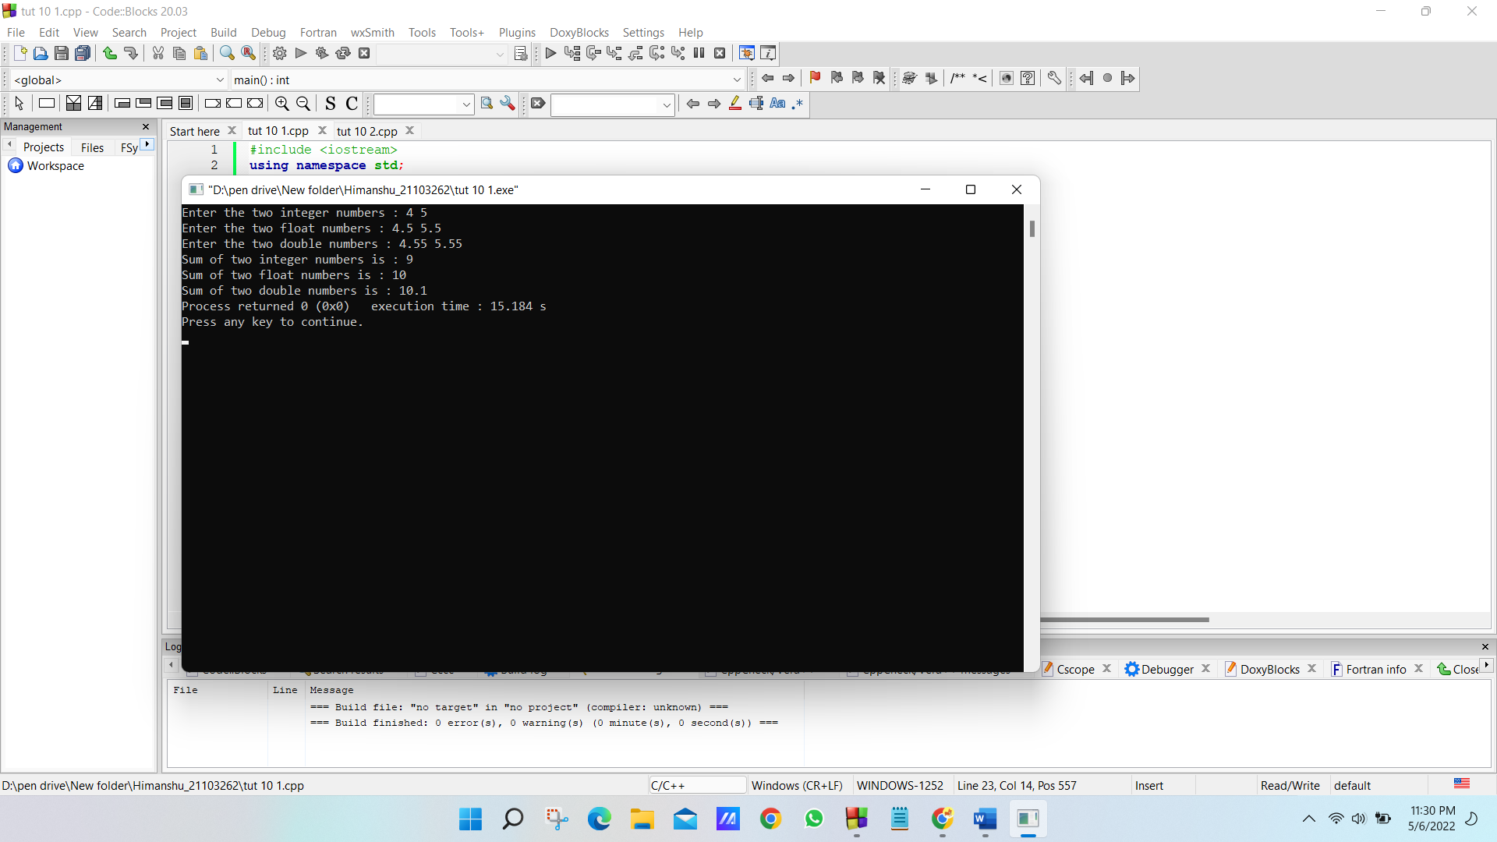

*2) Predict the output?*

*#include <iostream>*

*using namespace std;*

*template <typename T>*

*void fun(const T&x)*

*{*

*static int count = 0;*

*cout << "x = " << x << " count = " << count << endl;*

*++count;*

*return;*

*}*

*int main()*

*{*

*fun<int> (1);*

*cout << endl;*

*fun<int>(1);*

*cout << endl;*

*fun<double>(1.1);*

*cout << endl;*

*return 0;*

*}*

***Solution :***

x = 1 count = 0

x = 1 count = 1

x = 1.1 count = 0

*3) Predict the output?*

*#include <iostream>*

*using namespace std;*

*template <typename T> T max(T x, T y)*

*{*

*return (x > y)? x : y;*

*}*

*int main()*

*{*

*cout << max(3, 7) << std::endl;*

*cout << max(3.0, 7.0) << std::endl;*

*cout << max(3, 7.0) << std::endl;*

*return 0;*

*}*

***Solution :***

Error because in this code two different type parameter template is not given.

*4) Predict the output?*

*#include <iostream>*

*using namespace std;*

*template <class T>*

*class Test*

*{*

*private:*

*T val;*

*public:*

*static int count;*

*Test()*

*{*

*count++;*

*}*

*};*

*template<class T>*

*int Test<T>::count = 0;*

*int main()*

*{*

*Test<int> a;*

*Test<int> b;*

*Test<double> c;*

*cout << Test<int>::count << endl;*

*cout << Test<double>::count << endl;*

*return 0;*

*}*

***Solution :***

2

1

*5) Predict the output?*

*Assume that the size of char is 1 byte and size of int is 4 bytes, and there is no alignment done by the compiler.*

*#include<iostream>*

*#include<stdlib.h>*

*using namespace std;*

*template<class T, class U>*

*class A*

*{*

*T x;*

*U y;*

*static int count;*

*};*

*int main()*

*{*

*A<char, char> a;*

*A<int, int> b;*

*cout << sizeof(a) << endl;*

*cout << sizeof(b) << endl;*

*return 0;*

*}*

***Solution :***

2

8

*6) Output of following program.*

*#include <iostream>*

*using namespace std;*

*template <class T, int max>*

*int arrMin(T arr[], int n)*

*{*

*int m = max;*

*for (int i = 0; i < n; i++)*

*if (arr[i] < m)*

*m = arr[i];*

*return m;*

*}*

*int main()*

*{*

*int arr1[] = {10, 20, 15, 12};*

*int n1 = sizeof(arr1)/sizeof(arr1[0]);*

*char arr2[] = {1, 2, 3};*

*int n2 = sizeof(arr2)/sizeof(arr2[0]);*

*cout << arrMin<int, 10000>(arr1, n1) << endl;*

*cout << arrMin<char, 256>(arr2, n2);*

*return 0;*

*}*

***Solution :***

10

1

*7) Predict the output?*

*#include <iostream>*

*using namespace std;*

*template <int i>*

*void fun()*

*{*

*i = 20;*

*cout << i;*

*}*

*int main()*

*{*

*fun<10>();*

*return 0;*

*}*

***Solution :***

Error because I becomes 10 and we can not write 10 = 20;

*8) Predict the output?*

*#include <iostream>*

*using namespace std;*

*template <class T>*

*T max (T &a, T &b)*

*{*

*return (a > b)? a : b;*

*}*

*template <>*

*int max <int> (int &a, int &b)*

*{*

*cout << "Called ";*

*return (a > b)? a : b;*

*}*

*int main ()*

*{*

*int a = 10, b = 20;*

*cout << max <int> (a, b);*

*}*

***Solution :***

Called 20